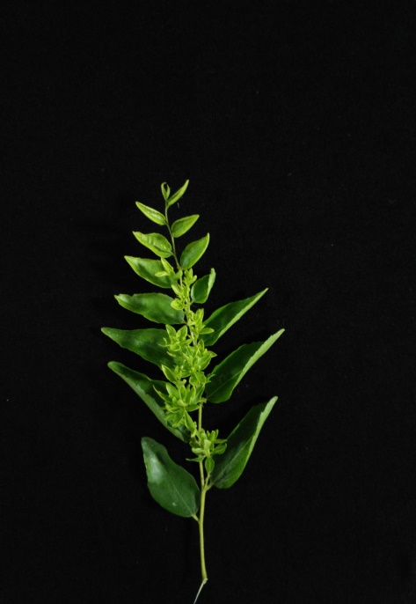
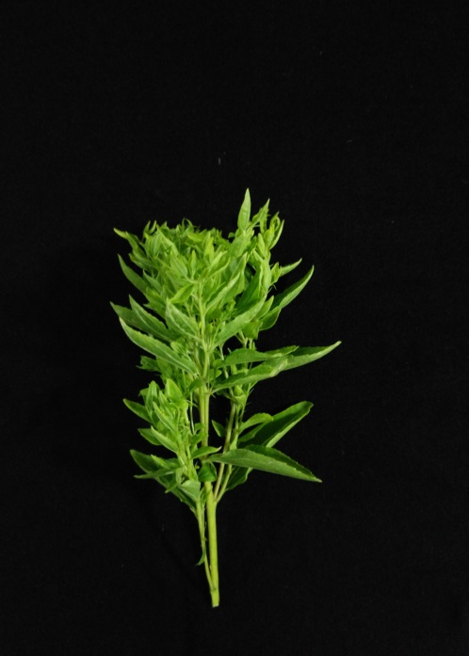
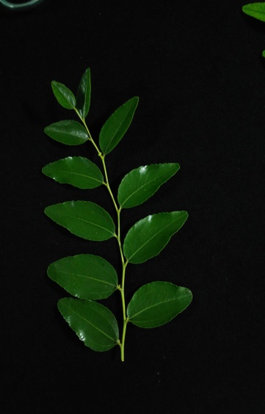
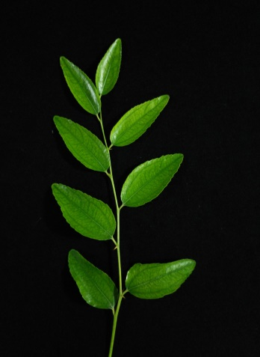
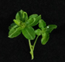
A

B

C

D

Additional file 4: Fig. S3 Tissues showing different JWB disease symptoms. A: Witches’ broom leaves; B: Phyllody leaves; C: Apparently normal leaves; D: Healthy leaves. A, B and C were used as a test group collected from diseased trees. D was used as a control collected from healthy trees.

